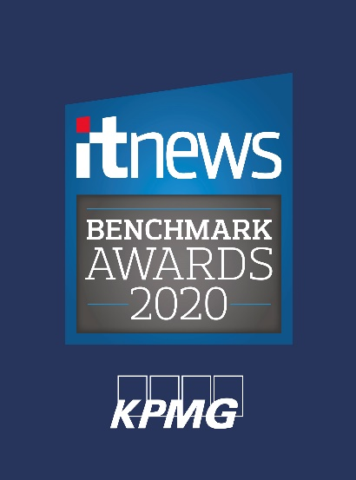
DUMMY ENTRY FORM – USE ONLY TO PRACTICE
Thanks for deciding to consider entering your project to iTnews for consideration in the 2019/20 iTnews Benchmark Awards.
Answering the questions below should take no more than 10-15 minutes. We aim to balance brevity with the right kinds of questions to determine the strength of your project execution and technology leadership.
Criteria
To be eligible for the 2020 iTnews Benchmark awards, your project MUST:
Have commenced after March 31, 2018, and been completed before September 30th, 2019. Be conducted by an Australian organisation or solely within the Australian subsidiary of a multinational organisation
Pilot projects are welcome, if testing with actual end-users or customers has completed.
Why enter?
- Become an alumni of Australia's premier IT awards program among the industry's top IT leaders. See all past winners here.
- Have your project covered in iTnews, which is read every day by tens of thousands of Australian IT professionals.
- Receive recognition in front of hundreds of your IT industry peers at our gala awards dinner in Sydney.
Winning projects will be covered in an iTnews Benchmark Awards micro-site, distributed digitally in March 2019.
All winners and finalists will receive a brand pack containing the awards logo to use on their social profile, email signature etc
2020 Awards categories
This year, the awards fall into three groups and we invite you to enter two awards! For example, a finance sector project focused on security could enter both categories.
The first group of awards are sectoral:
- Best Federal Government Project - Projects conducted by federal government departments or agencies that result in either internal efficiencies or improved citizen services.
- Best State Government Project - Projects conducted by state government departments or agencies that result in either internal efficiencies or improved citizen services.
- Best Local Government Project - Projects conducted by local governments that result in either internal efficiencies or improved citizen services.
- Best industrial and primary production project - Projects across all classes of industry – agriculture, resources, manufacturing – that demonstrably improve productivity or product delivery.
- Best education project - Projects conducted by or for educational institutions at all levels – childcare to University to adult education – that deliver either internal efficiency or better experiences and outcomes for students.
- Best health project - projects conducted by any organisation delivering health services that demonstrably improve staff productivity and/or service delivery to patients.
- Best mass-market project - This category is for projects that serve consumers, across retail, entertainment, transport or any other activities in which the end-user is a member of the public going about their daily lives! We suggest this category for companies focused on retail, media & entertainment, telecommunications services, tourism, transport and automotive. Projects should demonstrate improvements to internal operations and/or result in improved products and/or service delivery to corporate or retail customers.
- Best finance industry project - Projects conducted by participants in the financial services industries that either improve internal operations or result in improved products and/or service delivery to corporate or retail customers.
Next come the technology awards:
- Best resilience project - Projects that demonstrably improve an organisation's ability to withstand service disruptions, cyber-attacks, to ensure that internal users and/or customers face lesser risk of frustration or data exposure.
- Best internet of things project - Projects that use connected devices to gather and analyse data, then improve operations and/or products and services.
- Best emerging technologies project - Celebrating work in AR/VR, AI, drones, and other leading-edge technologies beyond the IoT.
And finally, the technology & society awards:
- Best diversity project - This category celebrates efforts to deliver products and services that are accessible to the maximum number of Australians, regardless of their ability, OR efforts by IT teams to make their teams more diverse in terms of any or all of race, ethnicity, gender, sexual orientation, socio-economic status, age, physical abilities, neurological ability, religious beliefs, political beliefs, or other ideologies;
- Best sustainability project - The sustainability category recognises projects that reduce resource consumption inside a business or in the wider community.
- Young Leader - This category celebrates a young IT leader – 35 years or younger – who has led significant change in an IT team.
Lastly, one project from among the category winners will be selected as AUSTRALIAN TECHNOLOGY PROJECT OF THE YEAR.
Submissions will be judged according to:
- The strength of the business case for the project.
- The project’s delivery – evidence of agility, creative applications of IT and competencies developed, whilst keeping within targeted scope, deadline and cost.
- Whether new ground was forged – in terms of innovation and new technologies or approaches, and how this risk was managed.
- Return on investment – anticipated or measured.
iTnews Benchmark Awards 2020
* 5. Please name your IT project for consideration:
(In fewer than ten words. Project must have commenced after March 31, 2018, and been completed before September 30th, 2019.)

* 6. Please provide a brief description of the technology project: (In fewer than 400 words)

* 7. What was the ultimate aim of the project? (In fewer than 50 words)

TECHNOLOGY
* 8. Was there any bespoke software development required by your team? What technology products were used?
(In fewer than 100 words)

9. Were the services of any technology services providers or consultancies involved? What did they contribute to the project?
(In under 100 words)

* 10. What return on investment was projected? What has been measured?
(Evidence of ROI will be weighted higher during the judging process)

* 15. How does this technology implementation set you apart from the rest of your industry? (Optional, in fewer than 200 words)

* 16. How did you manage change and win staff over to the new technology? (In fewer than 200 words)

* 17. How was the business case pitched to other senior stakeholders? How did you gain executive sponsorship?
(Optional, in fewer than 200 words)
YOUNG LEADER QUESTIONS
* 18. Please name the Young Leader for consideration (including job title):

* 19. Outline the leadership demonstrated and how it surpassed expectations (Have commenced after March 31, 2018, and been completed before September 30th, 2019.)

* 20. How was this success measured, and what impact did it have on the organisation?

* 21. Please provide statements from two internal referees willing to endorse the individual and their contact details.

22. How does this achievement set the individual apart from peers?
(Optional, in fewer than 200 words)

